**The second task of web and NLP**

**Picture of Robot map:**

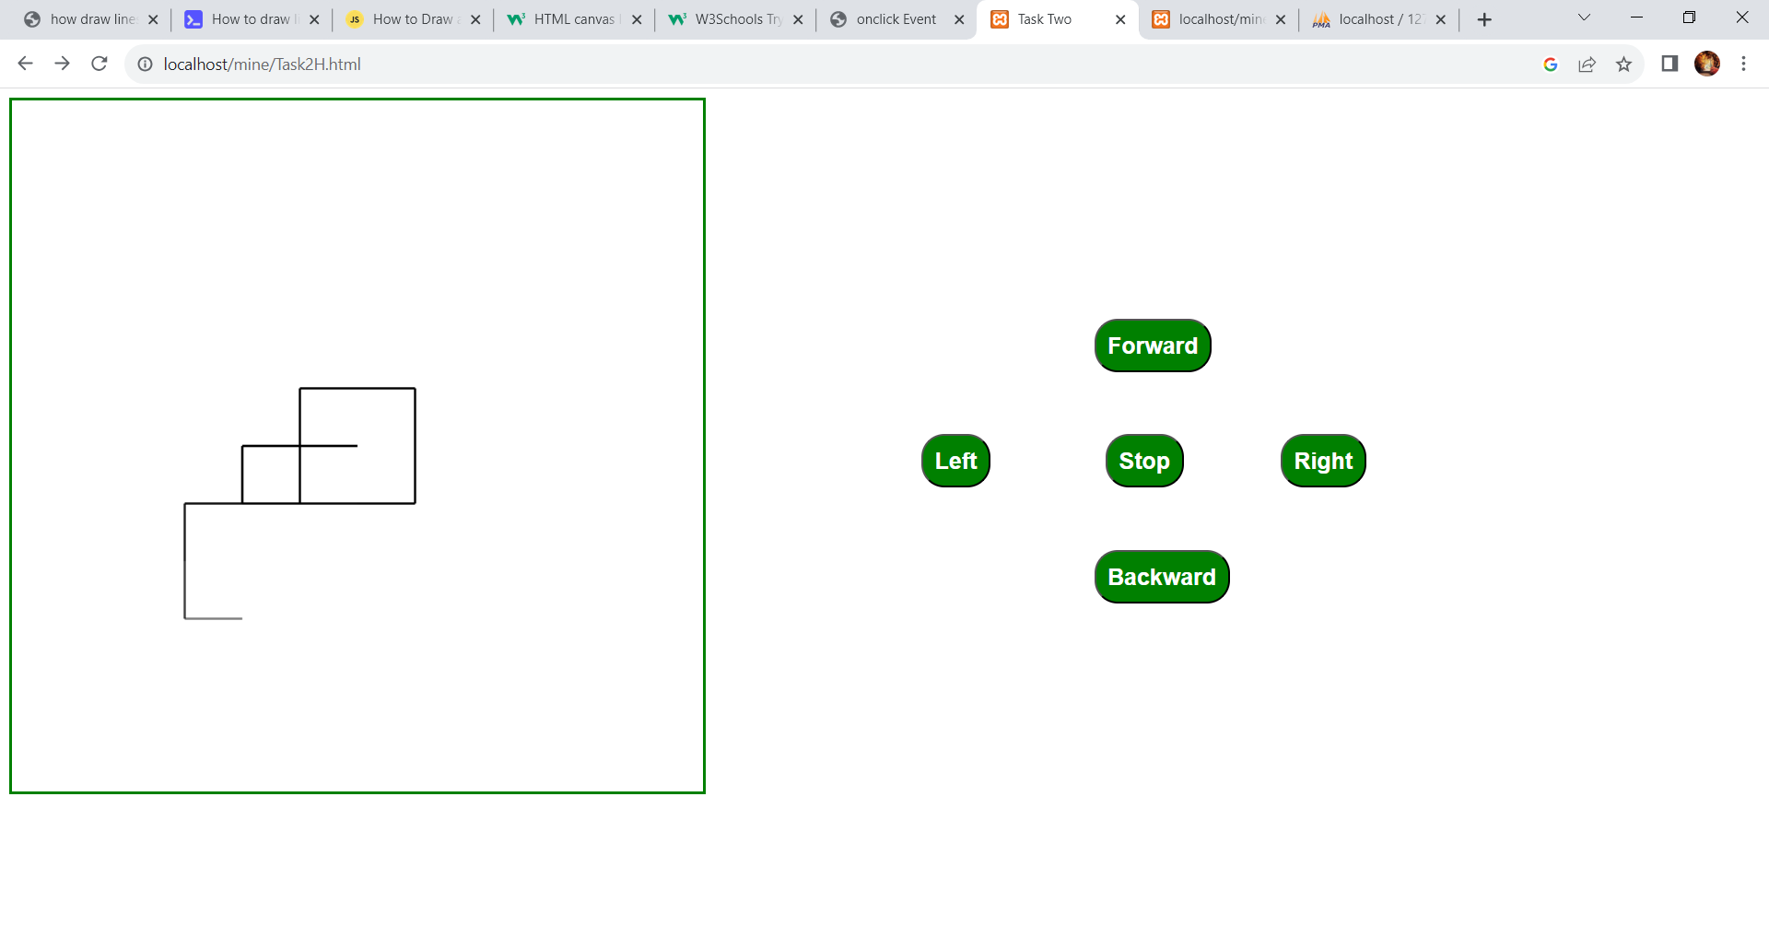

**Picture of the database:**

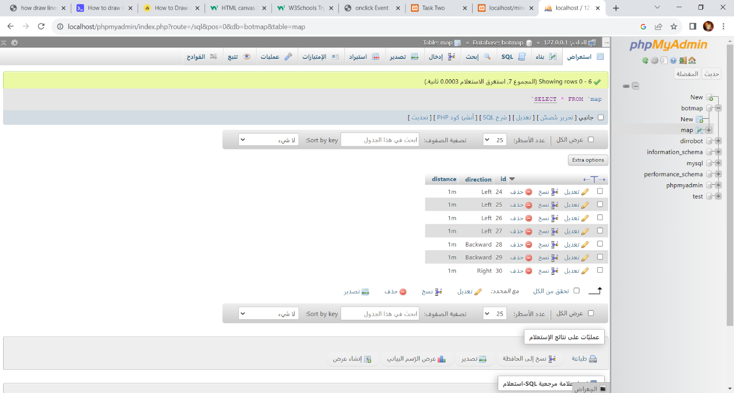

**Picture to show the path and direction of Robot :**

